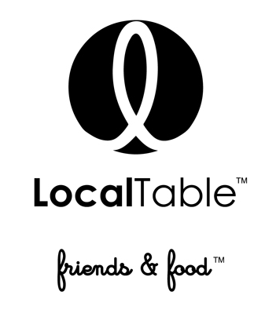
LUNCH Menu
First course
A choice of:
BANANA CAULIFLOWER SOUP |v| |gf|
Curry, turmeric, shallot, light cream, rainbow cauliflower, guajillo oil

AVOCADO TOASTS |v|
smashed avocado, house baked French baguette, roasted heirloom cherry tomatoes, shaved parmesan.
Second course
A choice of
Local BRGR
Classically made, a custom blend of fresh natural rib eye and New York strip loin is ground in house, griddled with generous amounts of clarified butter and locally sourced fresh (BFY) “better for you” toppings. Plus 1 side.
Add a cage free egg sunny side up. $ 1
Local Chicken |gf- without the bread|
SLOW COOKED CHICKEN WITH SMOKEY BARBECUE SAUCE
Skinless, boneless chicken legs and thighs, house blend BBQ sauce, kale and carrot slaw, Kosher pickles.
CAULIFLOWER STEAK |v|
Grilled cauliflower, truffle and wild mushroom bordelaise, shaved parmesan & angel hair pasta.
Third course
A choice of:
Chocolate mousse |made in house|
Chocolate mousse with crème brulee and flourless sponge
Chocolate caramel in jar |made in house|
Milk chocolate crème with salted caramel and chocolate sponge

$ 20 per person, not including tax and gratuity

