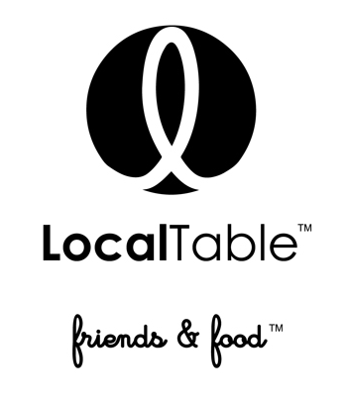
We strive to offer fresh, seasonal, natural & locally sourced food, which changes on a daily basis according to what the market offers that day.

DINNER Menu

FIRST
BANANA CAULIFLOWER SOUP |v| |gf|
Curry, turmeric, shallot, light cream, rainbow cauliflower, guajillo oil

SECOND A choice of:
WATERMELON CAPRESE |v| |gf|
watermelon, burrata cheese, heirloom cherry tomatoes, EVO, balsamic glaze and micro basil.
AVOCADO TOASTS |v|
smashed avocado, house baked French baguette, roasted heirloom cherry tomatoes, shaved parmesan.
Third A choice of:

L.T. MARY’S NATURAL CHICKEN BREAST |gf|
Framers market fresh baby carrots, sage, red quinoa, clover honey.
Pair with: Domane Wachau, Riesling or OKO, Malbec $12

SALMON EN PAPILLOTE|g|
Cooked in a paper bag, succulent and saturated with flavor of delicious mixture of farmers market fresh herbs and vegetables
Pair with: Girl Go Lightly, Rose $12

CAULIFLOWER STEAK |v|
Grilled cauliflower, truffle and wild mushroom bordelaise, shaved parmesan, angel hair pasta.
Pair with Recanati, White blend $12

NATURAL HANGER STEAK 8oz ($ 5. up charge)
Marinated 24 hours, natural hanger steak with rice noodles, grilled vegetables.
Pair with Recanati, Red blend $12

Fourth A choice of:
Chocolate mousse |made in house|
Chocolate mousse with crème brulee and flourless sponge
Chocolate caramel in jar |made in house|
Milk chocolate crème with salted caramel and chocolate sponge

Digetsif A GLASS OF PORT
$ 40 per person, not including tax and gratuity
If you have any type of food allergy or dietary restriction, please inform your server and our Chefs will be happy to accommodate you to the best of their ability.

